Space City Residents Take Small Steps for Values and One Giant Leap for Humanity

Walk for Values Team helps Houstonians to boldly walk for what no Texan has walked for before on May 2, 2009 in Downtown Houston, Texas USA
If there is righteousness in the heart, there will be beauty in the character.
If there is beauty in the character, there will be harmony in the home.
When there is harmony in the home, there will be order in the nation.
When there is order in the nation, there will be peace in the world.
- Sathya Sai Baba

This was the message that the Houston Walk for Values Committee took to the community, and about 500 Houstonians responded to this message and converged upon Discovery Green Park in Downtown Houston to symbolize their commitment to implementing Human Values in their lives. The participants were men, women and children from different backgrounds, race, ethnicity and cultures who believed that practicing values in their lives could help bring about change in the world today: a change that would take place over time, one person at a time.
Texas… The Next Frontier
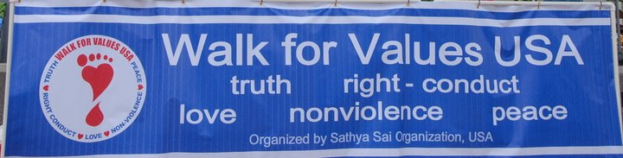
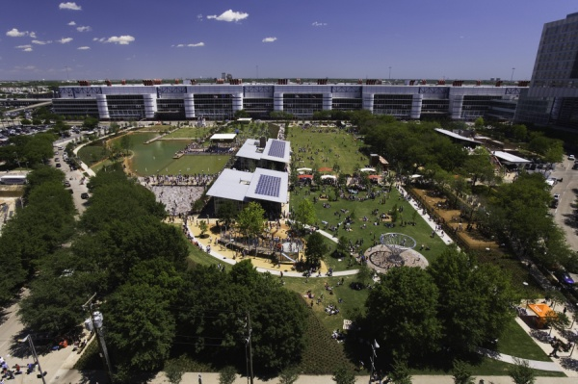
Regional officers, fresh from their return from Puttaparthi in July 2008, had one message ringing in their ears from Sathya Sai Baba: “What are you doing to take my message to the people of America?” This simple question lead to many brainstorming phone conferences with regional and local officers. The outcome was to reach out to the community and start the Walk for Values in different cities in the region. Walk for Values was originally started by the Sathya Sai School in Toronto, Canada. In 2008, the New York Region started Walk for Values USA. After linking up with the New York Committee, the Houston Walk for Values Committee was created by the end of 2008 and was comprised of officers and members from both North and South Houston Centers. One of the committee’s first tasks was to locate a suitable place for the walk to take place, evaluate amenities, costs, restrictions, and ease of access including parking availability and handicap accessibility. Out of 4 eligible candidates, Discovery Green Park in Downtown Houston was chosen; the required permits were procured by February 2009.
Discovery Green Park
Downtown Houston
(Aerial View)
Countdown stands at T minus 3… 2… 1(month)
The next challenge that the Committee faced was how to reach out to the community and spread the message of the importance of Human Values. The Committee created brochures that explained the importance of Human Values and their effects on our lives for distribution to members of the community. Invitation letters were sent to members from other groups, such as churches and schools, to join the Walk. To expand the base of exposure, pre-event articles and advertisements were placed in local newspapers. The editor of India Herald not only ran free pre-event articles promoting the walk, but also published an article on the front page of the newspaper after the walk. Additionally, radio stations ran free public service announcements. Committee members also went on the air during a radio talk show program called “Open Forum” to promote the Walk for Values and message of human values. The hosts for the radio talk show were impressed with the message of Human Values and the purposes and goals of the Walk and continued to promote the Walk even after the end of the segment. Additionally, the owner of the radio station willingly offered to promote the Walk on his own show which aired weekday evenings.
Committee members worked diligently on the actual preparation for the Walk day, included planning and designing of the Houston section of the Walk for Values website managed by the New York team, registration through the website and onsite, purchasing to Walk related shirts and hats, planning of the Opening and Closing Ceremonies, necessities needed during the Walk such as water, medical care, transportation for those unable to complete the walk and security, and post walk refreshments.
Houston, we have ignition…
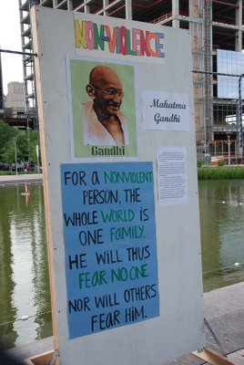
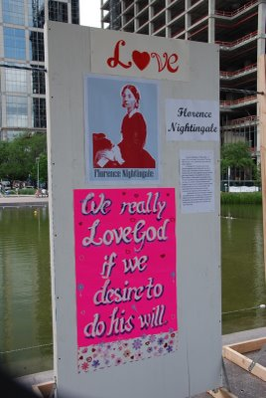
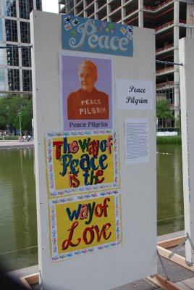
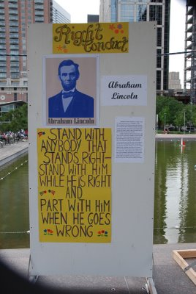
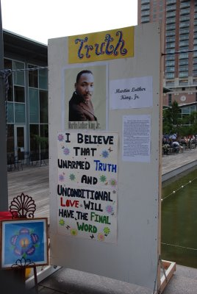
After months of planning, the actual day of the walk arrived. Bright blue skies, fluffy white clouds, and sunshine with plenty of breezes prevailed as over 500 Houstonians gathered on the lush green hillside of Discovery Green Park. A registration booth was set up for participants that pre-registered as well as participants who joined the day of the walk. After participants checked in at the Registration booth, they picked up a Walk for Values shirt and hat if they hadn’t done so before, and picked up a walker tag which displayed the value they were walking for. Face painting was also available for both the young and young at heart. Participants lined up on the grassy hill in 5 columns, one for each value, facing a large stage. The stage was decorated with five 7 foot tall wooden stands with posters created by the SSE children with a biography of a World Leader that exemplified each value presented: Truth - Martin Luther King, Right Conduct – Abraham Lincoln, Peace – Peace Pilgrim, Love – Florence Nightingale, Nonviolence – Mahatma Gandhi.
World Leaders and the values that they exemplify: Sai Spiritual Education Children created these posters and signage to instruct and inspire the participants and the general public.
The opening ceremony began at 2:00 pm with the introduction of the emcee for the walk, Isaih Carey from FOX 26 news, and followed by the U.S. National Anthem sung by female youth singers of the Sathya Sai Organization. Additional opening ceremony events included dances by the Sai Spiritual Education children to the songs: : “Put A Little Love In Your Heart” and “I Want To Walk a Mile In Your Shoes.” Keynote speakers included Sonal Buchar, a Fort Bend Independent School District Trustee, who spoke about “What is Peace?” and Houston City Council Member Peter Brown, who spoke about the history of Walk for Values and delivered a City Proclamation from Mayor Bill White declaring May 2nd as Walk for Values day. In a surprise guest appearance, Houston City Council Member Ronald Green also addressed the gathering, stressing the importance of human values and how it pertained to his own family.
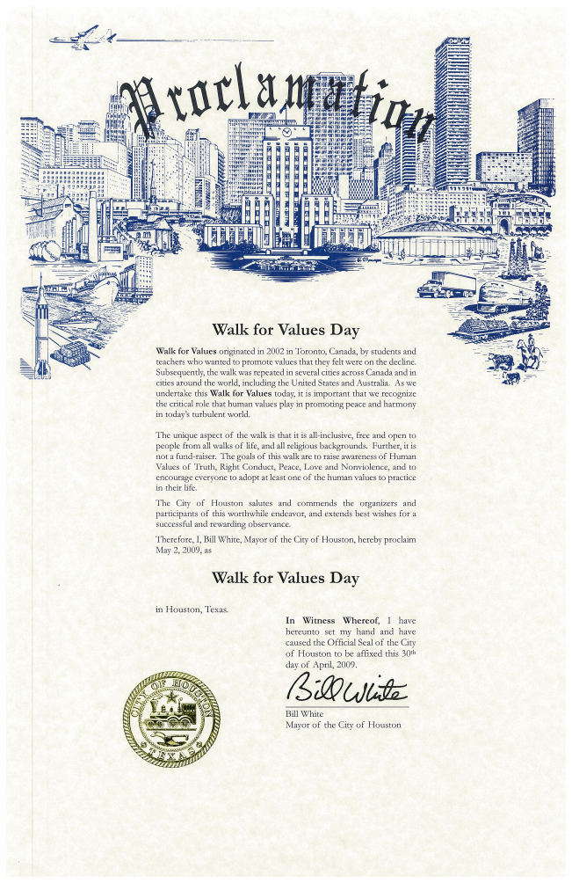
Fort Bend ISD Trustee Sonal Buchar
Emcee: Isaiah Carey from Fox 26 News

Houston City Councilmember
Ronald Green speaking on how values pertain to his family
Houston City Councilmember
Peter Brown reading the Proclamation

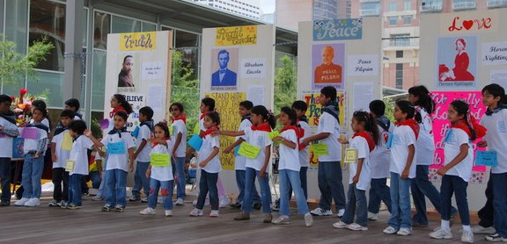
Children Dancing to “Put A Little Love in Your Heart”
We have Lift Off!!!
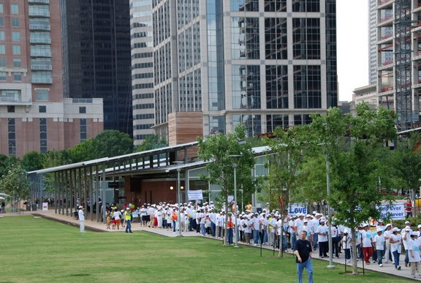
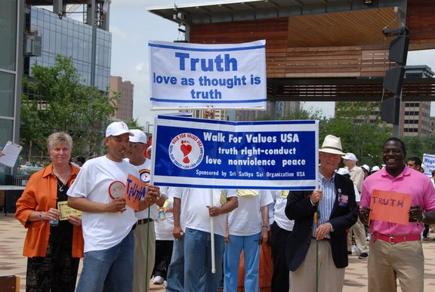
Upon completion of the opening ceremony, the peaceful walk of multitudes carrying signs and banners related to values proceeded through Discovery Green Park. Leading the walk was the Walk for Values Banner, followed by the Value of Truth and Houstonians who were walking for improving Truth in their lives. This was followed by Right Conduct, Love, Peace and last but not least, Nonviolence. The walk continued along Discovery Green Park and around several city blocks before returning to the park an hour later. Throughout the walk, security personnel from both the volunteer group of the Sathya Sai Centers of Houston and City of Houston ensured the safety of the walkers as they crossed busy city streets. The Lead Security Officer commented later that the presence and efficiency of the volunteer security team made their job much easier. The officers were also copiously and repeatedly thanked for their efforts by walkers as they crossed the streets. Half way through the walk, volunteers handed out water bottles to thirsty walkers. A shuttle van also accompanied the walkers stopping at pre-designated spots to help walkers who may not be able to complete the entire walk. During the entire walk, not a single walker availed themselves of this amenity. Even an 82 year old gentleman and his wife, and also a pregnant lady, hoping that her would be child would inculcate human values right in the womb, walked the entire route.
Participants walking out of Discovery Green Park
Dignitaries holding Walk for Values Banner at the start of the Walk

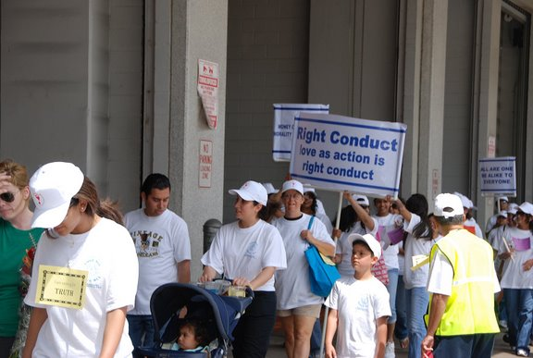
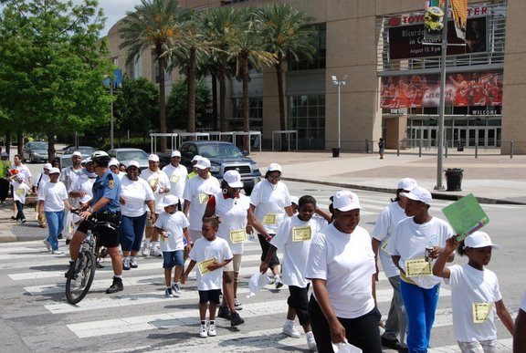
Walking down the streets of Downtown Houston
Crossing the street in front of the Toyota Center: Home of NBA Houston Rockets

Houston… The Eagle Has Landed!
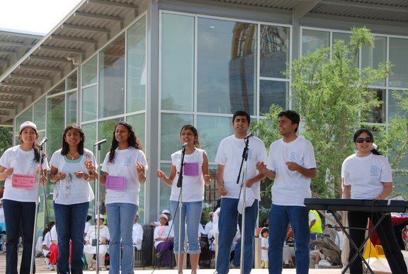
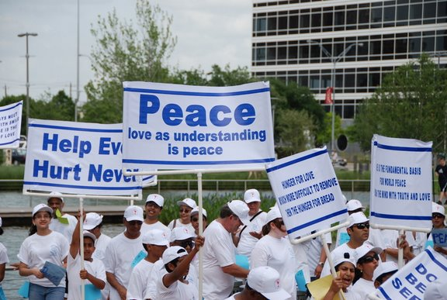
As the sea of participants made their way back to Discovery Green Park, they were greeted with cheers and congratulations. Tired, yet happy walkers rested on the lush slopes. Volunteers handed out cold refreshing water for the adults and cooled juice drink cans for the children. They also handed out healthy snacks to all of the walkers. Resting participants were treated to the closing ceremony which included an outstanding performance by a 13 year old vocalist Russia Bibbage from Clear Creek High School who sang “What’s Going On?” by Marvin Gaye and a Gospel song by Yolanda Adams. This was followed by a medley of songs by the youth singers of the Sathya Sai Organization, and inspirational talks by Perla Palileo, principal of Hartman Middle School who talked about the power of values and the difference it makes in the lives of underprivileged children. Rita Bruce, Human Values Activist, talked about the importance of values and how implementing even one value can make a difference in our own lives.

To the

Youth Singers of Sathya Sai Organization
Returning to Discovery Green Park

Perla Palileo, Principal of Hartman Middle School, talks about impact of values on underprivileged children
Rita Bruce, Human Values Activist, speaks on importance of values
Russia Bibbage, 13 year old vocalist, sings "What's Going On?” by Marvin Gaye

Future and Beyond
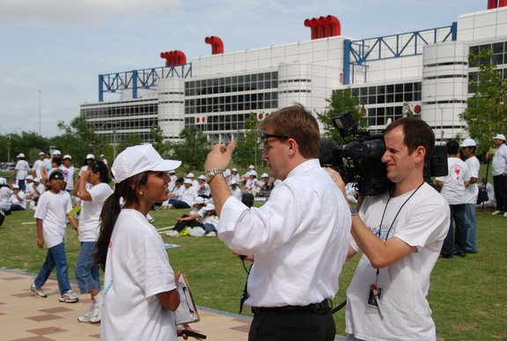
What’s next for the Houston Walk for Values Committee? Reflect upon the lessons learned and devise ways to improve it. Figuring out what worked and what didn’t work is the first step. Planning on how to improve the Walk is the next big task. How can we enhance participation? How can we broaden the outreach to reach to more communities? What improvements can be done to the opening and closing ceremonies? These are just some of the many questions that the committee will be working to find an answer to. Working harmoniously, the next Walk for Values – Houston will surpass the last one in its organization, participation and commitment to practice human values in our lives.
Walk for Values USA - Houston Committee member being interviewed by a FOX 26 News Reporter
What is needed today is that we should lead a life of good quality.
The fostering of sterling character and good conduct is the need of the world.
Once we have greater numbers of such people of good quality, the country and the world will become prosperous and peaceful.
- Sathya Sai Baba

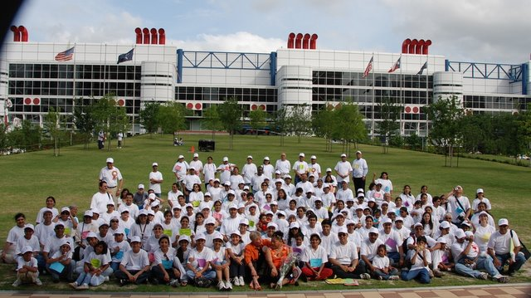
The race for mankind to return to its humanitarian roots of human values has begun! …with a Walk for Values!
Walk for Values USA - Houston Post-walk Group Photo

