Sri Sathya Sai Digvijayam:
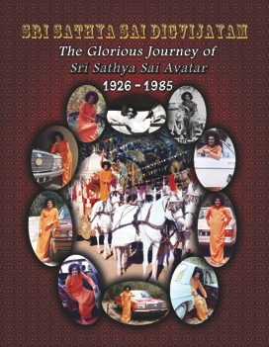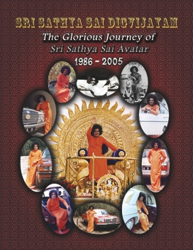
The Glorious Journey of
Sri Sathya Sai Avatar

In His Infinite Divine Grace, on the auspicious eve of the Maha Shivratri Festival at Prashanti Nilayam, on Tuesday, March 1, 2011, Bhagavan Baba blessed and released new publications entitled:
Sri Sathya Sai Digvijayam:
The Glorious Journey of Sri Sathya Sai Avatar

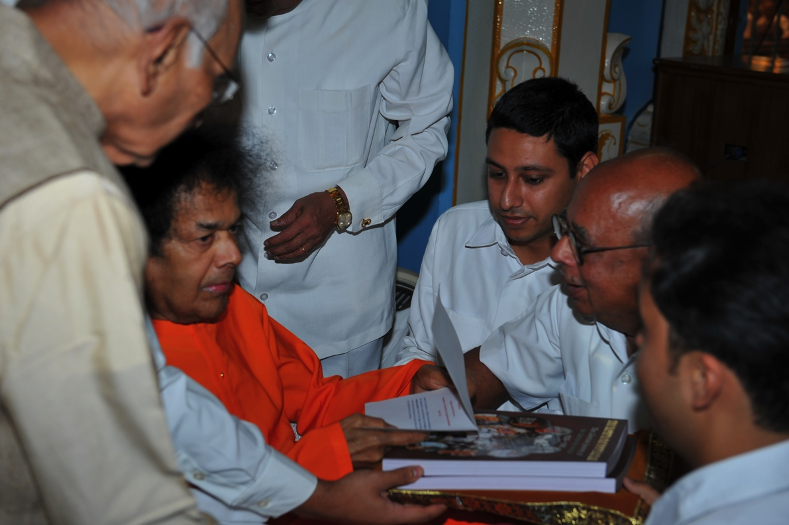
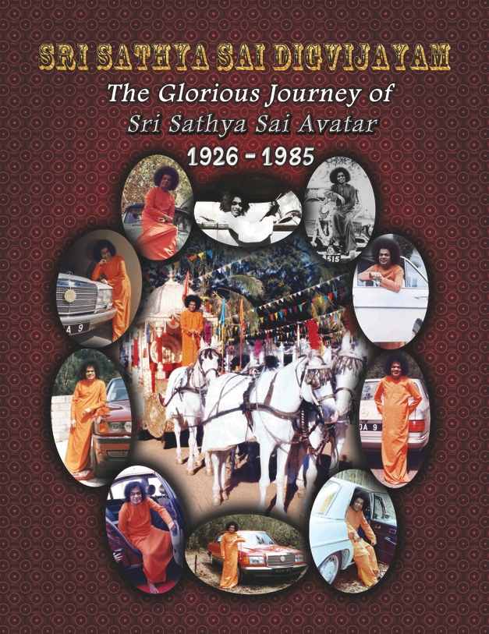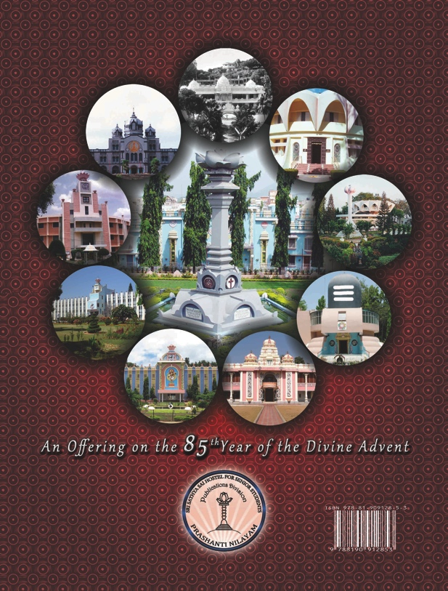
Part 1: 1926 – 1985

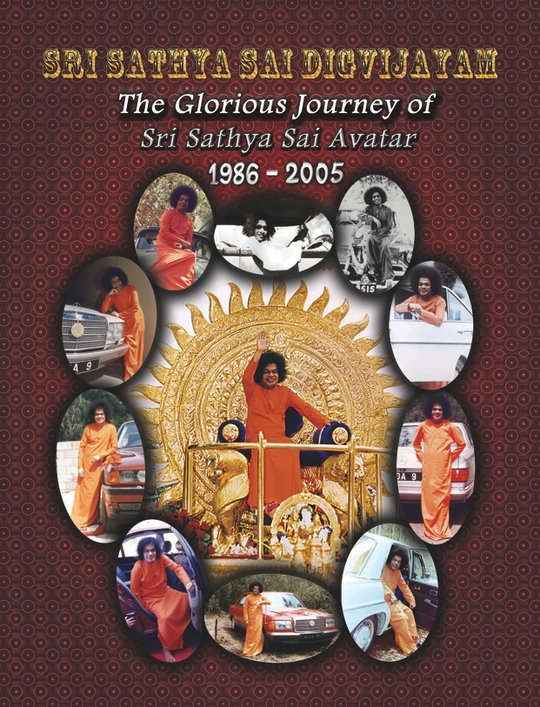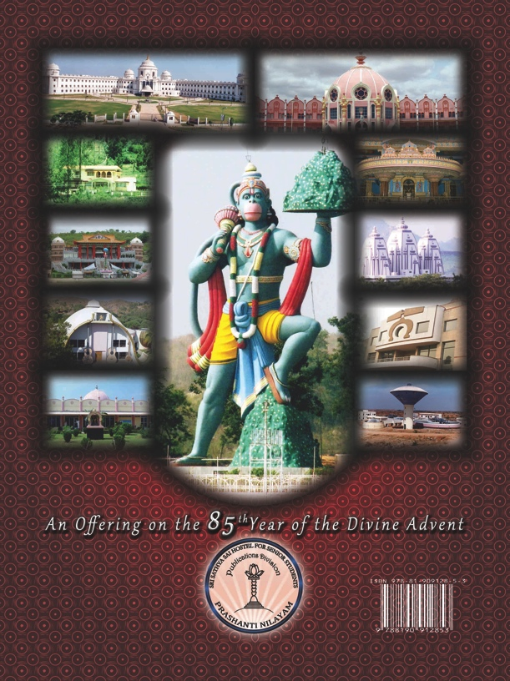
Part 2: 1986 - 2005

SRI SATHYA SAI DIGVIJAYAM – AN OVERVIEW

These books have culminated out of unprecedented efforts to record Bhagavan’s Life and Journeys over the last 8 decades. A day by day record has been documented from various authentic sources and literature available on His Life, Mission and Message. This literature consists of over 20 books including Bhagavan’s biography and other landmark documents on His life, as also the 564 volumes of the Sanathana Sarathi magazine from 1958 to 2005.

The rigours of these books are that of a research document which will be useful for posterity to know the various milestones in His life and multifarious journeys. The Book elucidates how Bhagavan has personally built this glorious edifice of the Sathya Sai Age. The places He visited, the individuals He blessed, the institutions He established, are all an eye opener of the Divine Master Plan. Each of these unfolds in the pages of this unique compilation.

It is overwhelming to note that in the last 8 decades Bhagavan has travelled over 3, 00,000 kms. A year by year account of the approximate distance travelled by Him has also been included in this Book. A detailed reference list of more than 200 places visited by Bhagavan over the last 80 years has also been provided as an annexure.

The books contain an incredible collection of nearly 350 rare photographs of Bhagavan, collected from different parts of India and the world, from the years 1938 to 2005. Each of these has been grouped in a chronological manner through a total of 36 photo collages covering 80 years of the Avataric sojourn, a rare treat for the readers. There are special collages on Divine visits to Africa, Kashmir, Ooty and Kodaikanal. The cover pages of each of the volumes symbolise the various journeys Bhagavan has undertaken over the years. The back cover pages of each of the 2 volumes depict the major institutions established by Him during the given period.

As a humble offering on the occasion of Bhagavan’s 85th Birthday, this first of its kind compilation has been prepared by the Chaitanya Jyoti Museum through an ongoing effort of over 6 years (2004-2010). The students of the Sri Sathya Sai University have played a very important and vital role in the designing, formatting, proof reading and the creative facets of the books.

The books provide an ideal reading for all – students and spiritual seekers; researchers and professionals; administrators and academicians; doctors and devotees of Bhagavan.
The entire set containing over 600 pages of reading material and 350 rare photographs has been reasonably priced at INR 400/=.

Enquiries, if any, may be addressed on the following e-mail ids:
- chaitanyajyoti_psl@dataone.in;
- sai.publications@gmail.com;
- ihs99999@gmail.com

By the end of March 2011, copies will be available at:
- Chaitanya Jyoti Museum, Prashanti Nilayam
- Sri Sathya Sai Sadhana Trust – Publications Division
Book Stores, Prashanti Nilayam
- Dharmakshetra Book Stores, Mumbai
- Sundaram Book Stores, Chennai

*********

